**ICT 351: Test Two: 1:30 minutes**

1. Consider the simple regular expression below, simply them and provide the meaning for expression. 8 marks
   1. *L*( a*b* ) =
   2. *L*( (a ∪ b)* ) =
   3. L((a ∪ b)*b) *=*
   4. *L*( (a ∪ b)*abba(a ∪ b)* ) =
2. Consider the following regular grammar G:

S → aT

T → bT

T → a

T → aW

W → ε

W → aT

1. Write a regular expression that generates L(G).
2. Use grammartofsm to generate an FSM M that accepts L(G).
3. Build a PDA to accept each of the following languages *L*: {a*i*b*j* : 2*i* = 3*j* + 1}.
4. Build a PDA to accept each of the following languages L: {w ∈ {a, b}* : every prefix of w has at least as many a’s as b’s}.
5. Build a PDA for {*w* ∈ {a, b}* : every prefix of *w* has at least as many a’s as b’s}.
6. Build a PDA for AnBn = {anbn: n ≥ 0}
7. Let Σ = {a, b}. For the languages that are defined by each of the following grammars, do each of the following:

*i*. List five strings that are in L.

*ii*. List five strings that are not in L.

*iii*. Describe L concisely. You can use regular expressions, expressions using variables (e.g., anbn, or set theoretic expressions (e.g., {x: …})

* 1. S → aS | Sb | ε
  2. S → aSa | bSb | a | b
  3. S → aS | bS | ε

**Solutions**

Simplify and provide meaning 4 marks

* 1. *L*( a*b* ) ={a}*{b}*
  2. *L*( (a ∪ b)* ) ={a, b}*

It means go through a loop zero or more times and each time choose an a or b

It is a set of all strings over the alphabet {a, b}

* 1. L((a ∪ b)*b) *=* {a, b}*{b}

It means go through a loop zero or more times and each time choose an a or b

It is a set of all strings over the alphabet {a, b} that end in b

* 1. *L*( (a ∪ b)*abba(a ∪ b)* ) ={a, b}*{abba}{a, b}*

It means go through a loop zero or more times and each time choose an a or b, then choose the substring abba, then choose an a or b.

It is a set of all strings over the alphabet {a, b} that contains the abba as substring

Regular grammar G 4 marks

(b ∪ aa)* a

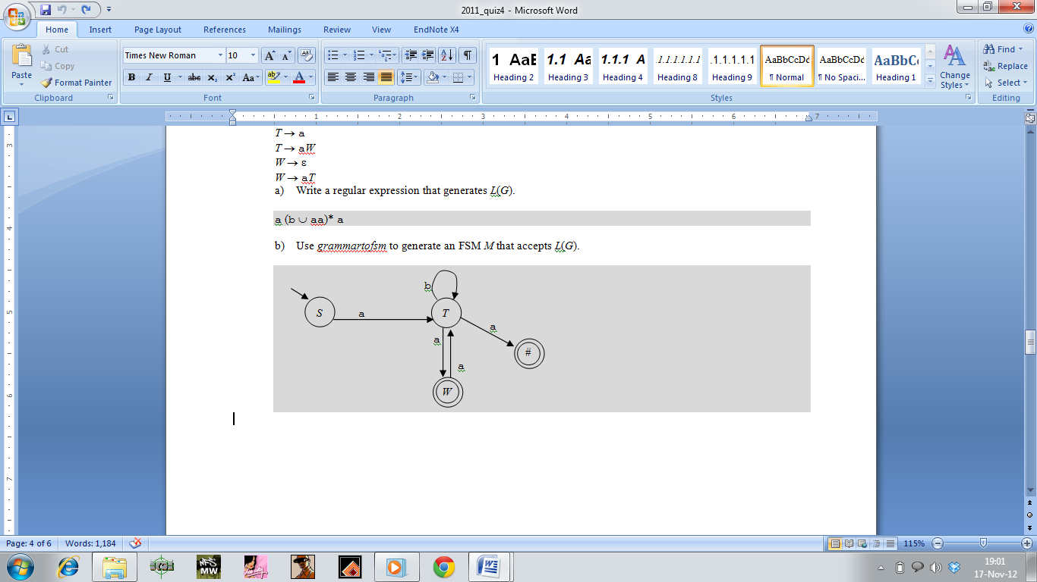

Build PDA 3marks

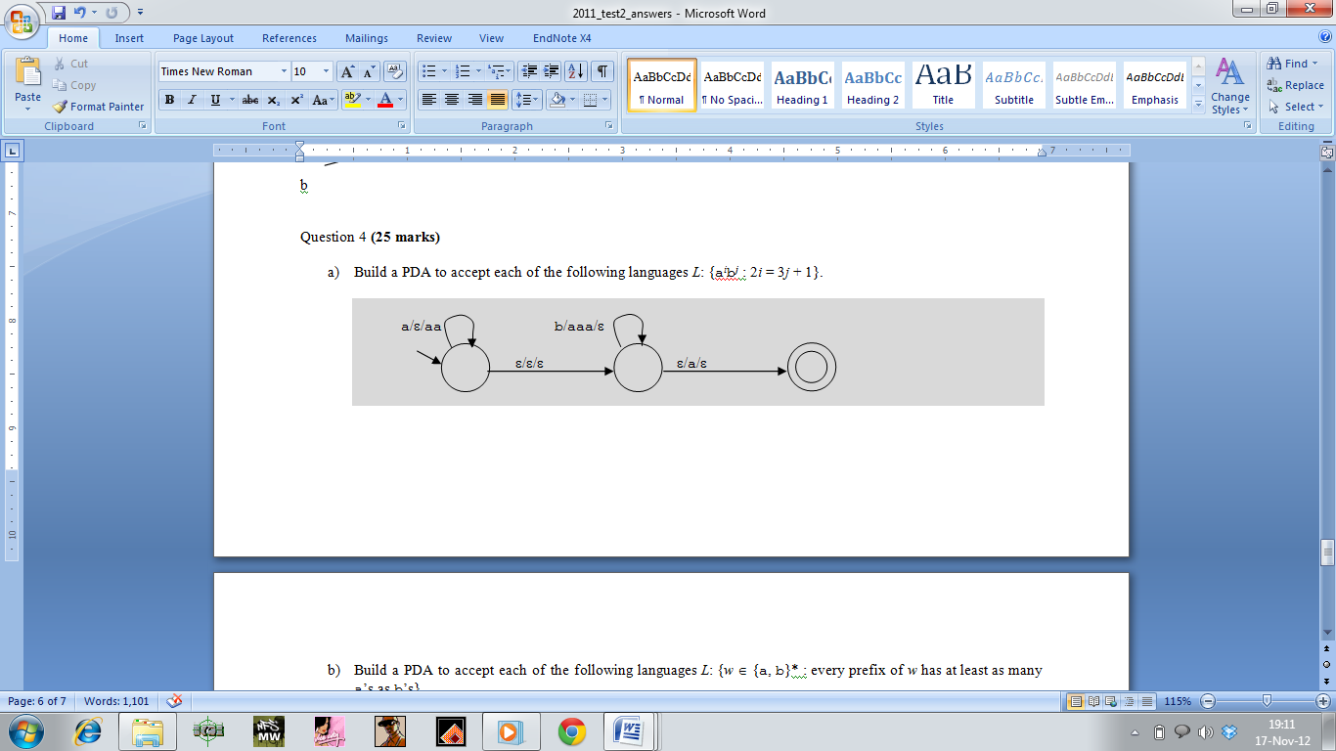

Build PDA 2 marks

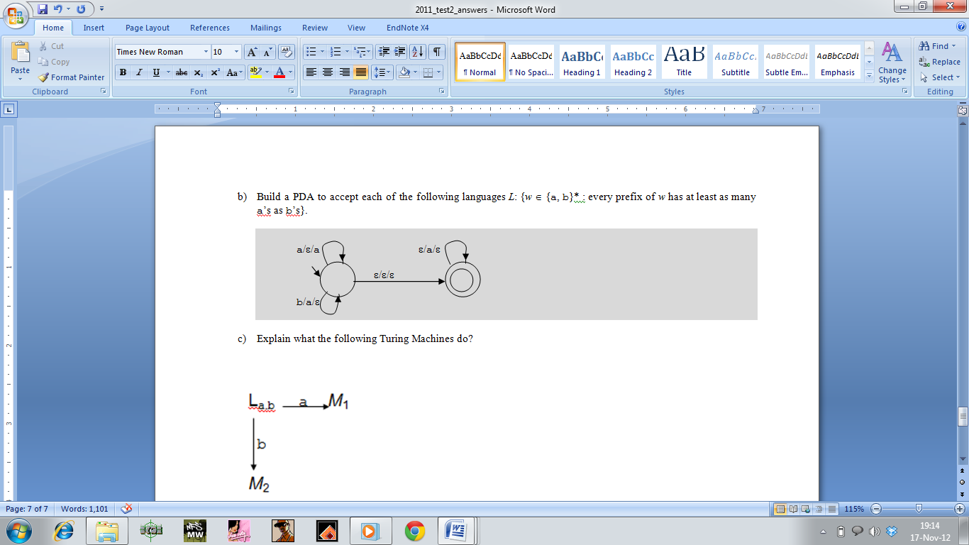

Same as above

Build PDA 3 marks

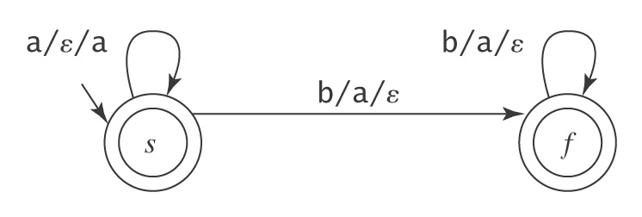

Do each of the following 9 marks

